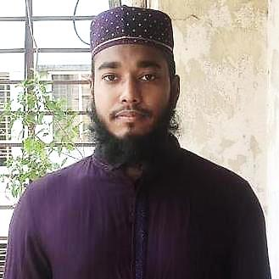

BIODATA

|  |
| --- |
| **PERSONAL INFORMATION** |

Name : Md Anwar Hossain

Father’s Name : Md Abjal Mollah

Mother’s Name : Saleha Begum

Date of Birth : 01-03-1996

Religion : Islam

Nationality : Bangladeshi

Blood group : AB (+)

Height : 5 Feet 7 Inches

Occupation : Software Engineer

Company : Motion Soft (Software Company of Motion View)

Office Address : 10/25 Eastern Plaza 10th Floor CR Datta Road, Hatirpool, Dhaka-1205.

|  |
| --- |
| **EDUCATION INFORMATION** |

B.Sc-In-CSE : City University | 2018-2022

Diploma Eng. : Faridpur Polytechnic Institute | 2012-2016

S.S.C : Talma Nazimuddin High School | 2012

|  |
| --- |
| **CONTACT INFORMATION** |

Contact No. : 01794030592

Email Address : anwarhossain7736@gmail.com

Address : Goherpur, Rahutpara, Talma, Nagarkanda, Faridpur.

Present Address : Kathal Bagan, Free School Street, Hatirpool, Dhaka-1205.

Guardian No. : 01768060096